Lancia’s Decadent Spice-Nut Chocolate Chip Banana Bread

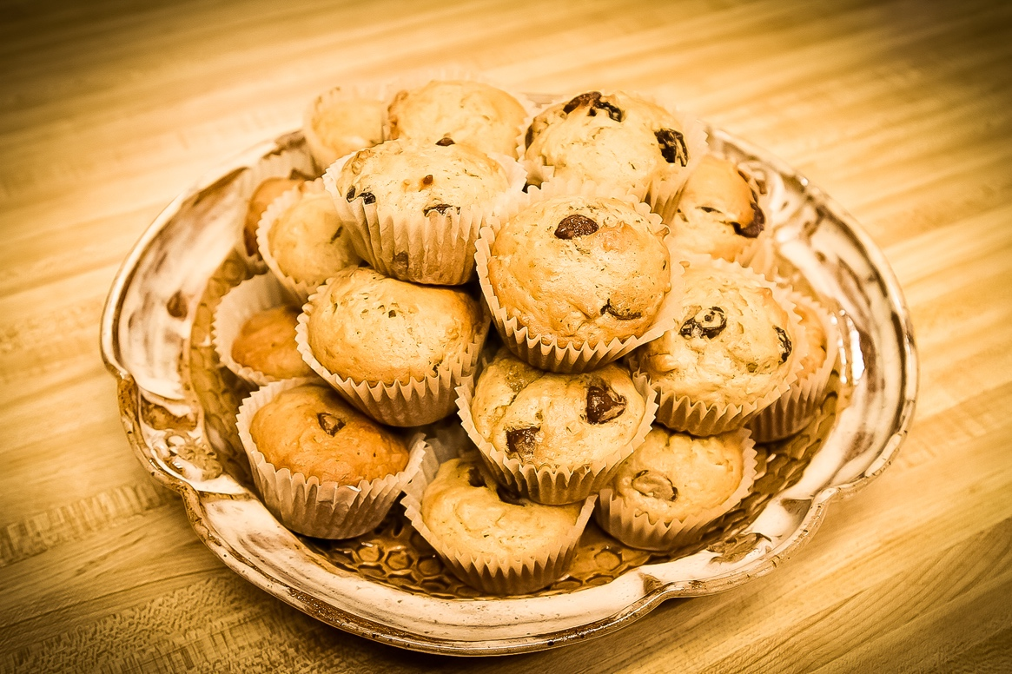
Many years ago in what seems like a land far, far away (Boulder, Colorado) I was a caterer for a few years. One of the most requested offerings I ever made during those years is this decadent treatment of banana bread. In fact, the only thing that was requested more from my menu was my original version of Beloved Chicken Soup. My children loved it long after I stopped catering to clients and catered only to them. Even today, my husband Peter gives these sweet treats an A+, (which he knows is the only grade I like!)
A helpful tip when baking these - don't try to answer "just one email" while they are baking, or go out to cut "just a few stems for the bouquets." One burned pan of Chocolate Chip Banana Bread batter is not worth the email or the stems.... Trust me. I know what I'm talking about here. ;-)
Siftable Ingredients ~
3 1/2 cups unbleached baking flour (I like King Arthur or Red Mill about equally.)
2 1/2 t. Baking Power
1 t. Baking Soda
2 t. spices ~ cinnamon, nutmeg, allspice
1/2 t. salt
Cream-together Ingredients ~
2/3 cups softened Kerry Gold Butter (salted) (I know there are other brands of butter, but I have long since stopped using them.)
1 1/2 (one and a half) cups brown sugar
4 large brown eggs (I like brown eggs best and for the most part, those are the only kind I've ever used.)
4 T. Whole Milk
1 T. vanilla
*2 cups mashed very ripe bananas

The Embellishments ~ Hold till the batter is made!
1 cup coarsely chopped fresh walnuts (Smell them - if they are too old they will smell rancid and taste bitter. No amount of sugar or chocolate can hide that taste!) You can also substitute walnuts with Pecans. Some sweet folks do not like walnuts, some don't like any nuts at all.
1 cup fresh raisins - big is better
1 bag (12 oz) Milk Chocolate Chips (I only use Guittard Milk Chocolate chips. They are so good I have to hide them in secret containers because in their packages they would be devoured by the man I live with upon discovery!)
1/2 cup of unsweetened coconut

Steps to make the batter:
1. Assemble ingredients
2. Sift all the dry ingredients together - flour, baking powder, baking soda, spices, and salt - Keep separate.
3. Cream soft ingredients - butter, eggs, sugar, vanilla, milk in a large mixing bowl. But NOT the softened bananas.
4. Mash the bananas till something like pudding - but leave some little chunks - don't make it into soup! Keep separate.
5. In the large mixing bowl with the creamed ingredients, ADD half the sifted flour mixture and stir together. It will be quite stiff. Then add HALF the mashed bananas and stir together. When blended, stir in the remaining half of the sifted flour mixture and add the last half of the mashed bananas. You will have a thick batter at this point. Don't overwork it or stir too long.
6. Now add the decadence! Chopped Walnuts, Raisins, Shredded Coconut, and Chocolate Chips.
Steps for Baking:
1. Preheat your oven to 350°F.
2. Choose the form you want to bake the batter into. You can choose to make this into standard size loaves for slicing, mini-loaves, little Bundt pans, standard muffin size, or even mini-muffins. It is delicious no matter what shape or size! I make mine in standard muffin size for ease of serving and storing.
3. For standard muffin size - line the cups with baking parchment paper cups. It will save you all kinds of time later in clean up and keeps the serving process clean and lovely. :-)
4. Fill each cup halfway - do not fill to the top. Leave room for these to expand or they will overflow and stick to the pan top.
5. For muffins, bake for APPROXIMATELY 15-22 minutes in the center of a pre-heated oven. Every oven is different. Watch for the top to begin to brown. If you are not sure that they are done stick a knife blade, toothpick into the center of one of the muffins. If it comes out clean, they are done. If not, continue baking for a few minutes. My husband likes his softer, I like mine a little crispier on the top. A few minutes makes a big difference.
6. When they are done, take them out of the oven and promptly take them out of the pan (leaving the parchment paper on them, not in the pan.)
7. Promptly eat while warm! Save what you can, covered in an airtight container leaving plenty of room for the muffins so you don't smash them!
These make wonderful gifts for neighbors and friends, also. Watch what happens when you share some!

The featured image is courtesy of Lancia E. Smith and used with her glad permission for
Cultivating and The Cultivating Project.

